JEDI

Shirt, Trouser, Tunic with fixed Tabs, Wrap Belt and Jedi Cloak
Anakin; faux leather Tabs
YARDAGE;
Shirt/lining 5.5m Cotton or similar
Trousers 2m Cotton or similar
Tabard 5m Cloth,
we used Viscount ‘BLADES’
Cloak 6.5m Thickish Cloth,
we used Viscount ‘BLADES’

MAKING COSTS;
Whole Outfit £170
Cloak £55
Tabard and sash £70

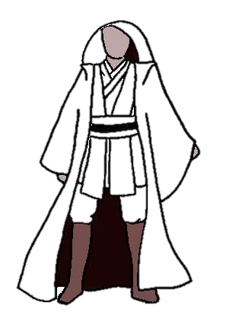
JEDI OUTFIT
NAME and ADDRESS

1-SHOULDER  2-SHOULDER TO WRIST  3-CROSS CHEST  4-CHEST [FEMALE-BUST]  5 -WAIST  6 -HIPS  7-INSIDE LEG  8-OUTSIDE LEG  9-SOULDER TO GROUND  10-SHOULDER TO SHOULDER  11-CROSS BACK  12-NAPE TO WAIST  13-SHOULDER TO HEM OF JEDI TUNIC  14-ROUND ARM  15-ROUND WRIST | 